ABOUT RAVEN SR

Raven SR is a clean fuels company that transforms waste – municipal solid waste, organic waste, and methane – into high-quality, clean hydrogen and Fischer-Tropsch (FT) synthetic fuels through our uniquely patented Steam/CO₂ Reforming technology. Our process is non-combustion, producing fewer emissions, and we can process multiple and mixed wastes simultaneously. The clean, renewable fuels we create from this carbon-neutral conversion will reduce and eliminate vast amounts of waste contributing to greenhouse gases, pollution, and climate change.

PARTNERS & PRODUCTION LAUNCH

- The first waste-to-H₂ production facility will be in Richmond, CA with operations projected to begin in 2024.
- The first gas-to-hydrogen production facility in 2024 in Southern California.
- Several SAF production facilities are in the planning stage in the U.S., Asia and Europe
- Raven investors include: Chevron, Itochu, Hyzon Motors, Ascent Hydrogen Fund, Samsung Ventures, Stellar J, and RockCreek
- Raven and Hyzon Motors are partnering to build 250 hydrogen hubs globally to fuel Hyzon’s zero-emissions commercial truck fleet.

RAVEN SR’S TECHNOLOGY

- Is one of the only combustion-free, waste-to-hydrogen processes in the world, designed to reduce emissions and produce more hydrogen per ton of waste than competing processes.
- Our patented Steam/CO₂ Reformation technology is a chemical process versus combustion.
- We use a wider range of feedstocks that can be mixed together and do not require sorting.
- Our syngas has a very rich hydrogen content (~60%) compared to competing technologies, enabling us to produce higher quantities of renewable hydrogen or FR fuels, such as Sustainable Aviation Fuel (SAF) and Renewable Diesel (RD), at a lower price.
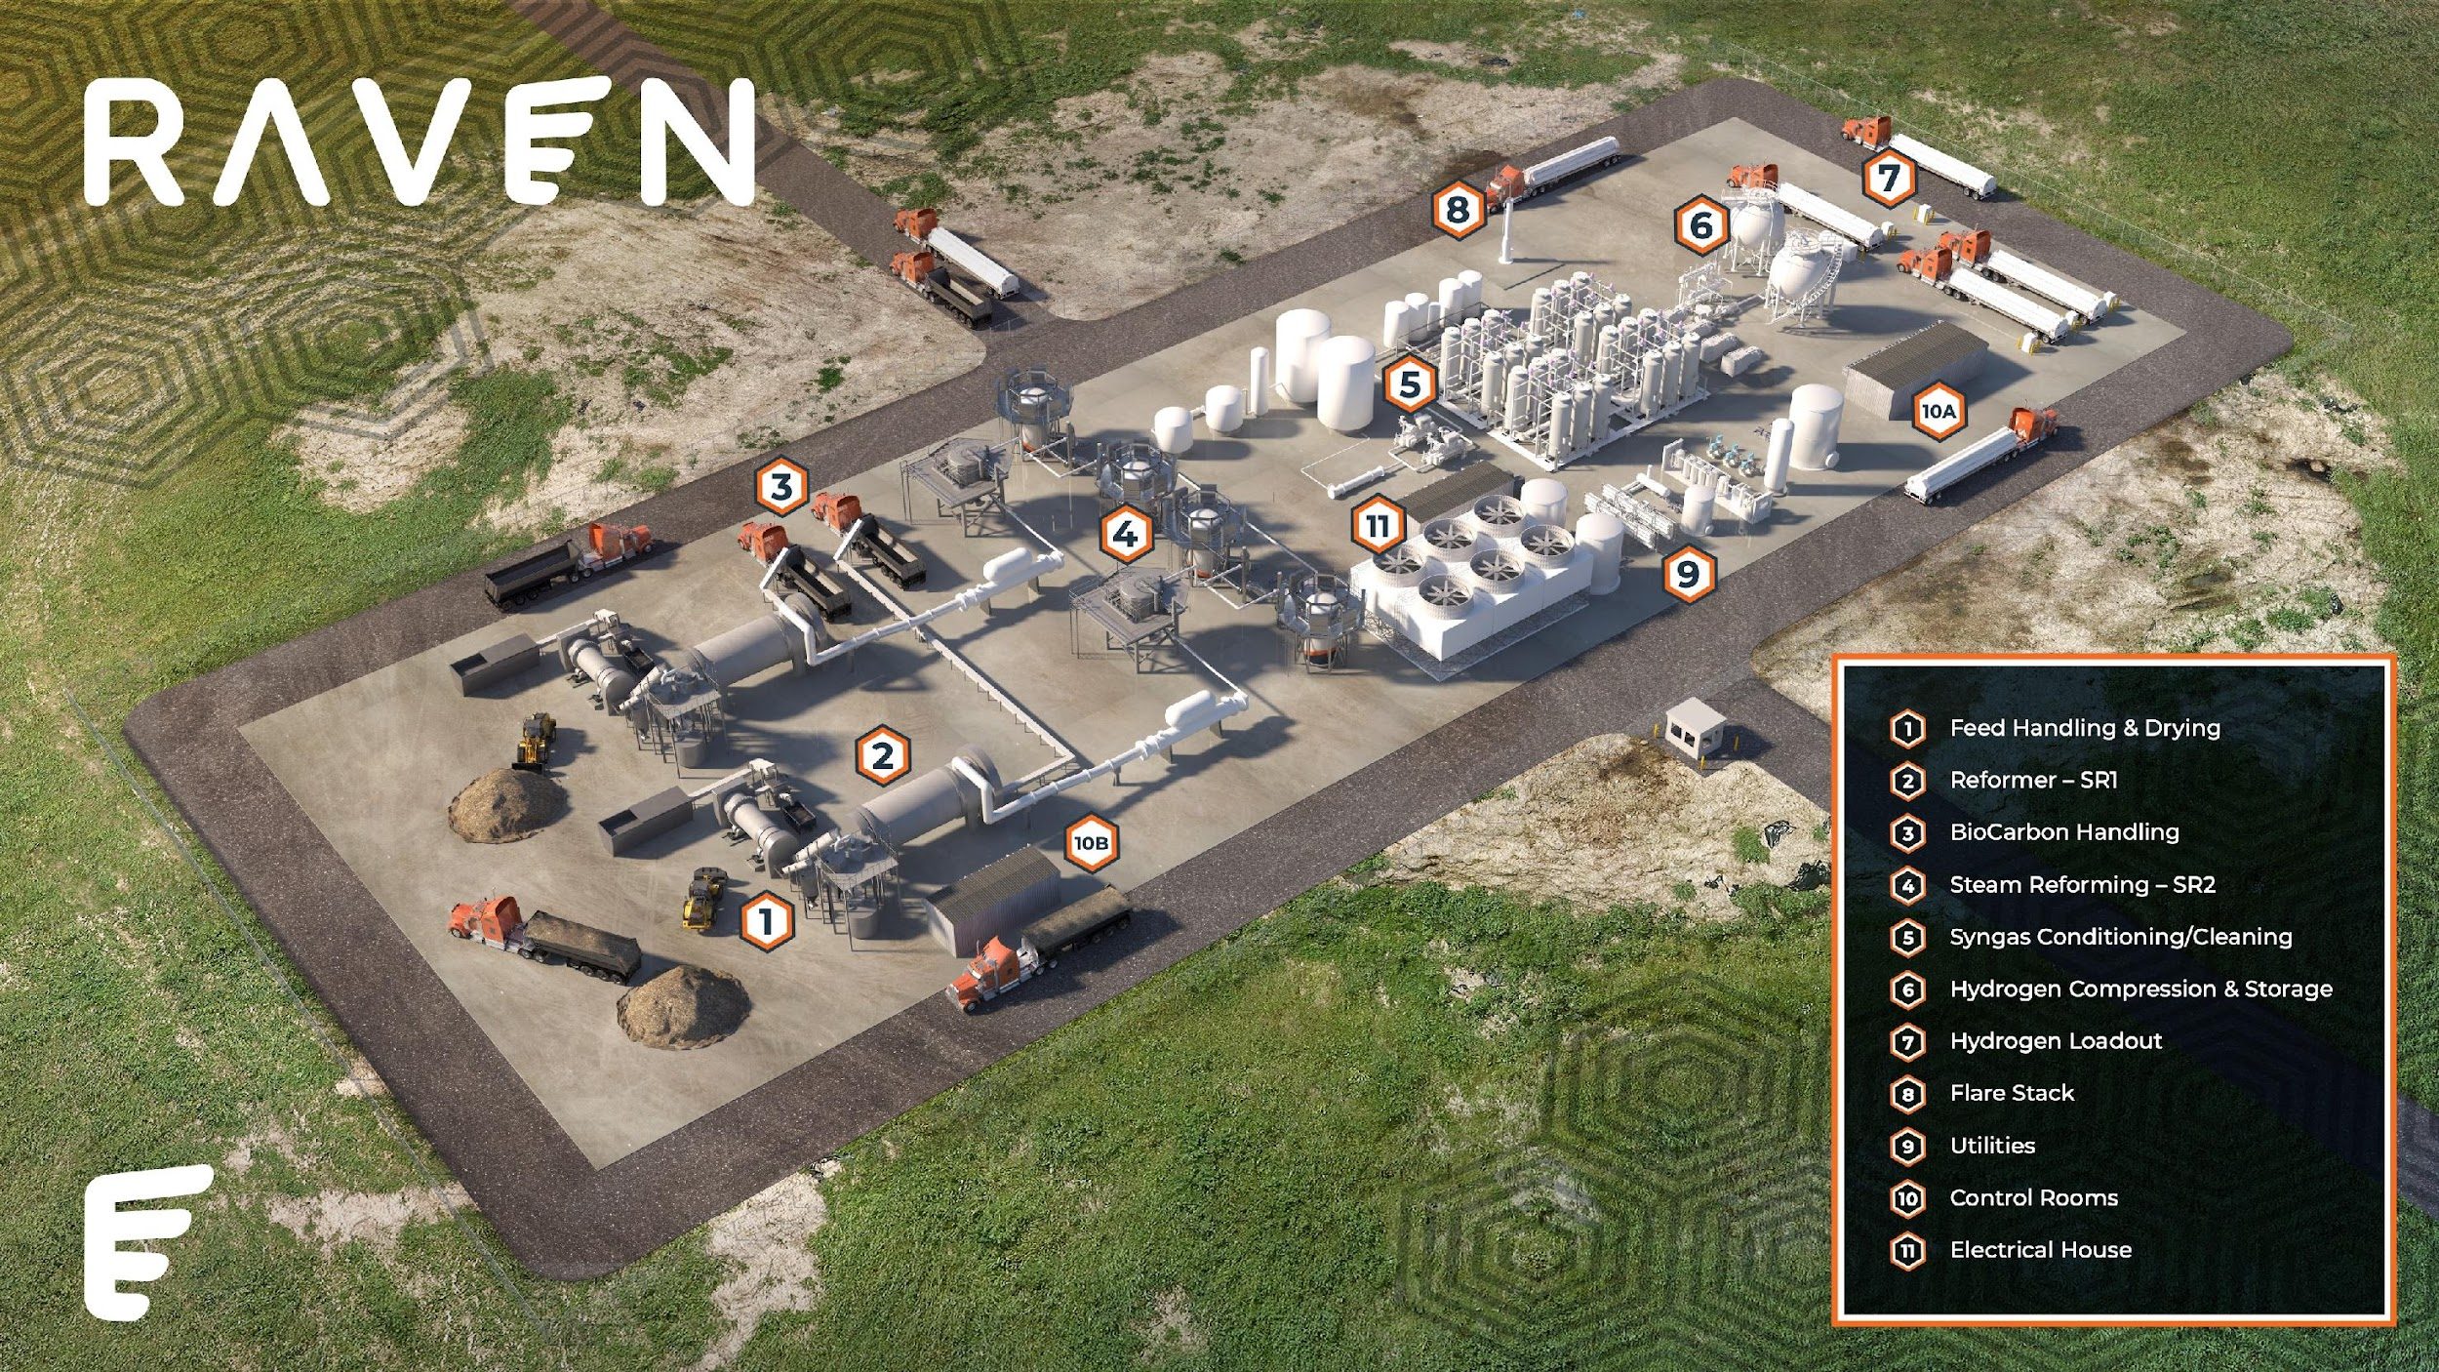
- Our modular and scalable units can be placed at landfills and agricultural sites. Our production facility in Richmond, CA is approximately 2 acres. (Left). Our proposed SAF facility is approximately 4 acres. (Right)
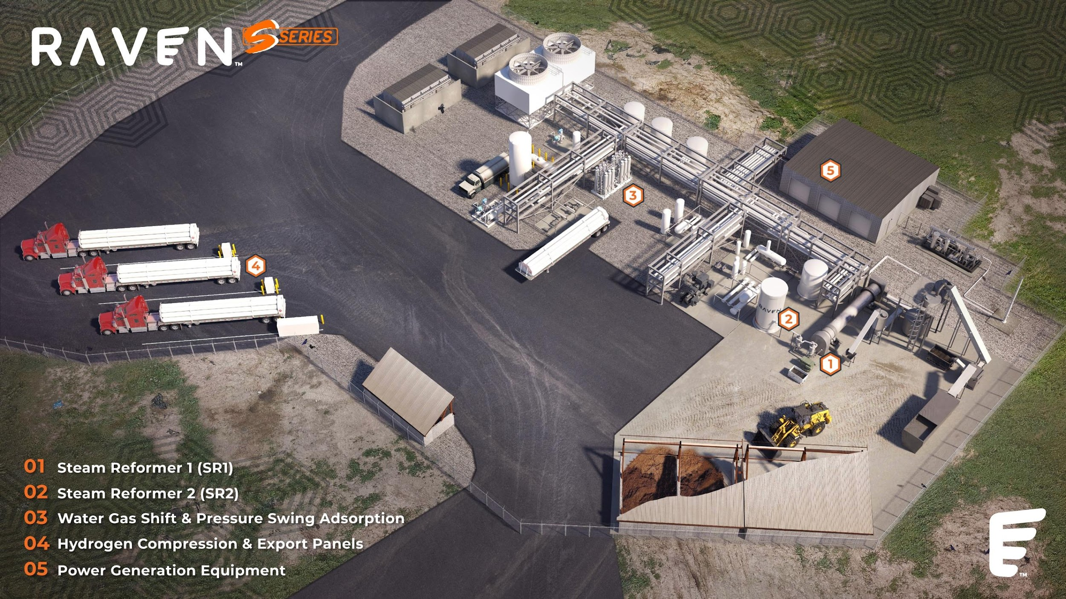

GREEN PROCESS

Key features that differentiate the Raven SR system, making it greener than competing systems:
- Air emissions are 2.5 times less than the best available technology.
- The process has been approved by the California Bay Area Air Quality Management District.
- Our carbon intensity score varies by feedstock but is expected to be low or carbon-negative.
- Our waste streams do not need to be dried, reducing energy needs.
- We do not use fresh water. We recycle, and even manufacture any water required, and depending on the feedstock, can be completely water neutral.
- Units can be autonomous, using hydrogen and syngas produced for power instead of pulling from the grid.

WASTE STREAMS & SUPER POLLUTION REDUCTION

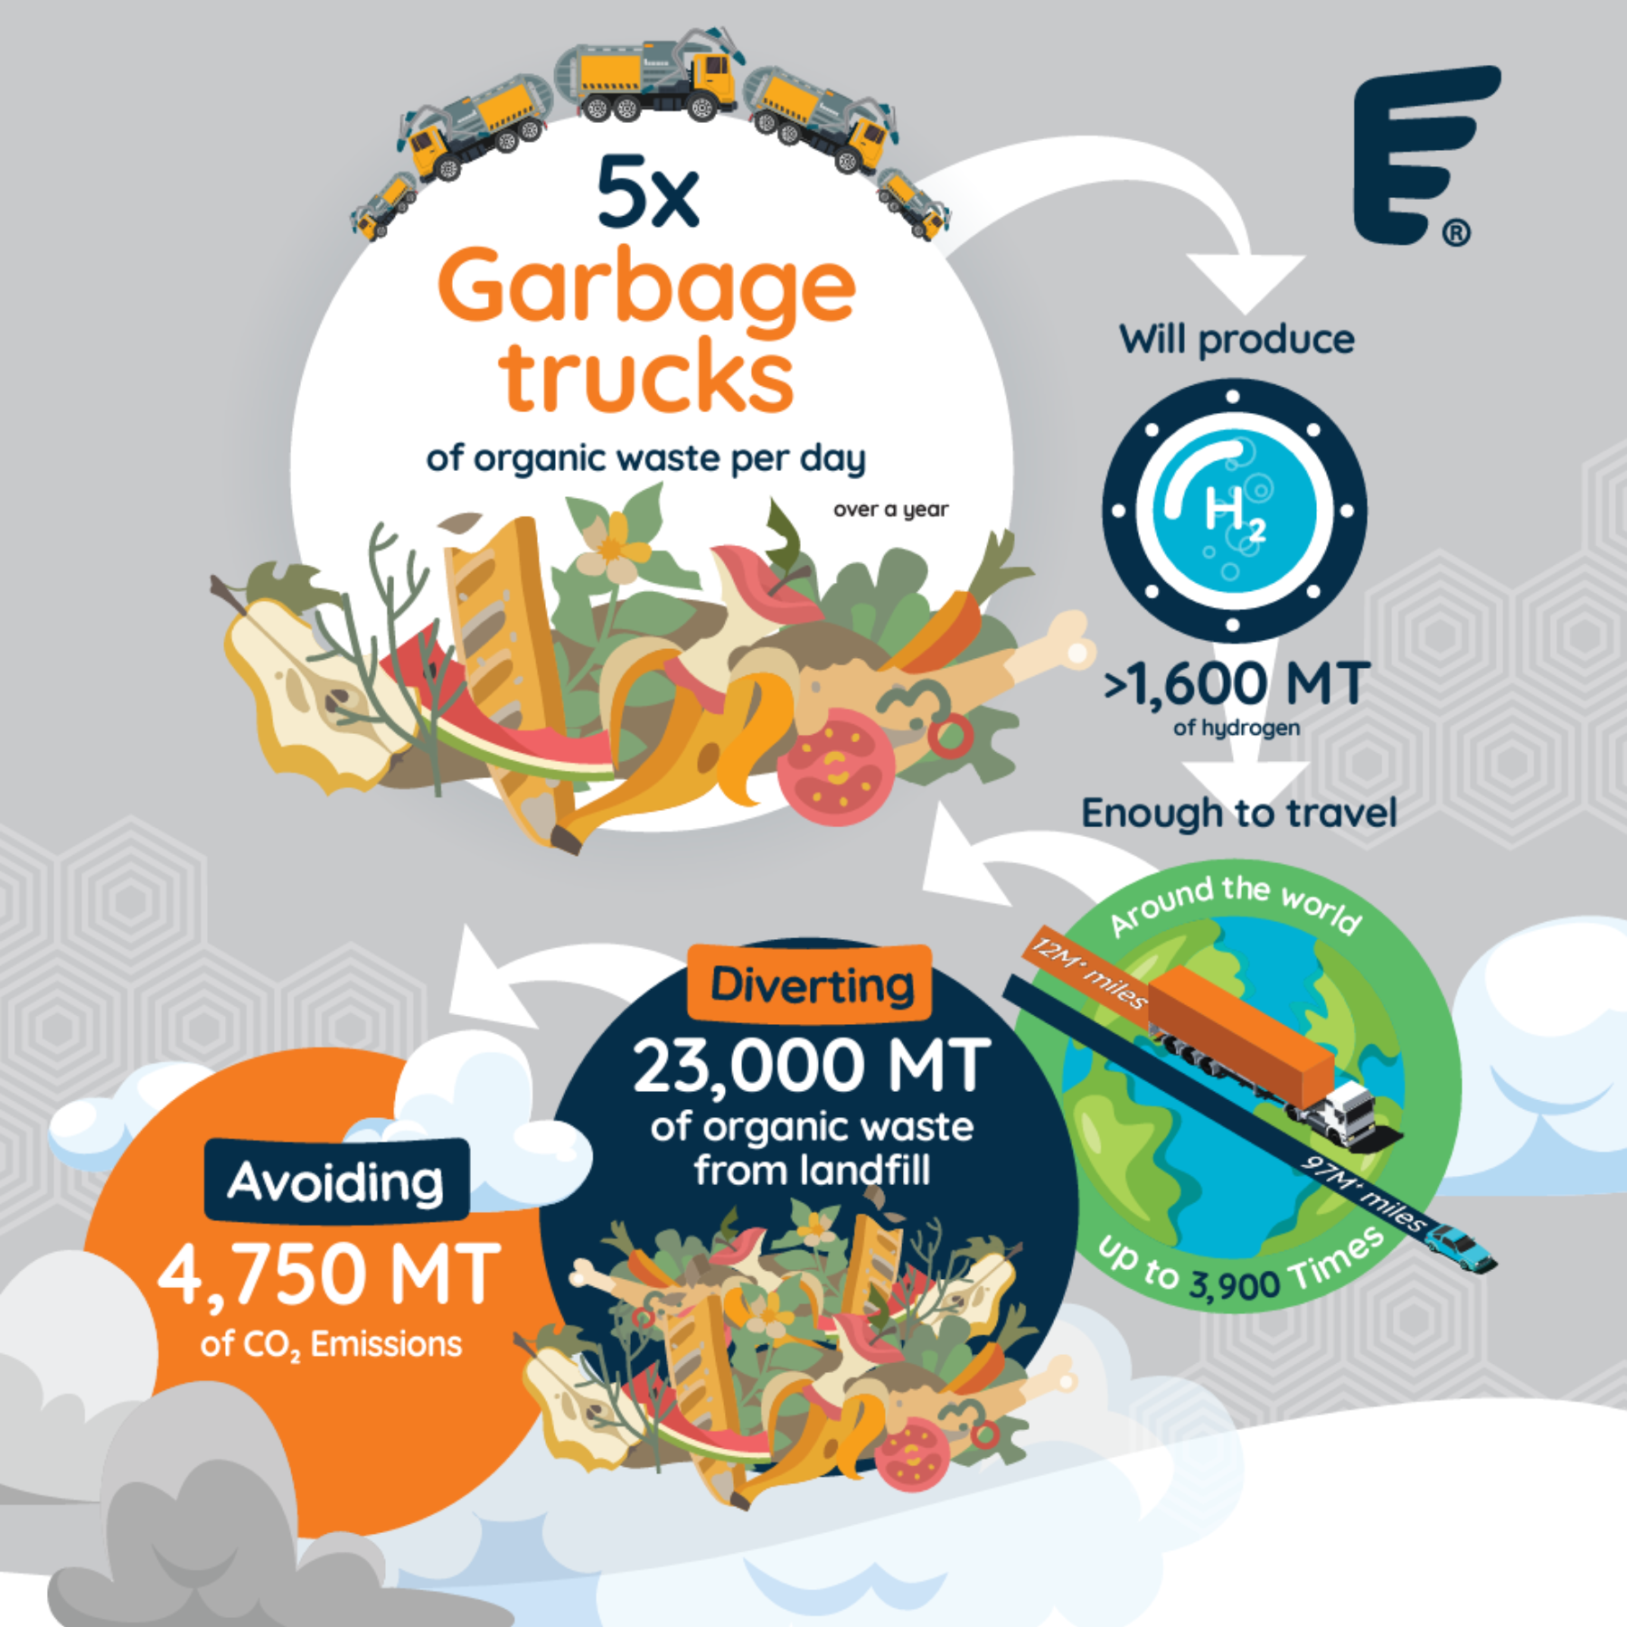
Raven SR’s fuel production can significantly cut greenhouse gas emissions by eliminating landfill waste and converting it to renewable fuels.

The most urgent step we can take to slow climate change is to cut the super “Short-Lived Climate Pollutants” which are tens to thousands of times more damaging to the climate than the carbon dioxide emitted by fossil fuels. The biggest source of these emissions is organic waste sent to landfills.

Annually, by converting just 5 garbage trucks per day of organic waste, Raven:
- Creates more than 1,600 MT per year of 99.999% pure hydrogen
- Which fuels 97 million miles in a passenger car or 12+ million miles in a Class 8 truck
- Avoids 4,750+ MT of CO₂e from landfills
- Diverts 23,000 MT of waste from landfills

YIELDS GREEN OUTPUTS & CARBON NEGATIVE EMISSIONS

The Raven process produces hydrogen or FT fuels, which are considered renewable fuels depending on the feedstock.
- Raven’s process per day produces 4.8 MT of hydrogen or FT fuels, and 14 MT of bio-carbon from 99 MT of biogenic waste, using 4.5MW power, with no pure water required. Raven is further designing the systems to generate its own power onsite in order to be independent of the grid.
- Raven’s process can be carbon-negative because it diverts waste from landfills, reduces methane or black carbon from organic waste, and can be fully autonomous, using the energy created by its fuels to power its facilities.
- Raven’s technology creates hydrogen from waste in larger quantities than other technologies, turning pollution into green energy at a cost that will enable the widespread adoption of hydrogen as a source of energy.
- FT fuels are synthetic fuels (sustainable aviation fuels and renewable diesel) that are purer and burn more cleanly. FT fuels have higher energy content per carbon content, and are less dense than conventional fuel, allowing aircraft to fly further on the same load of fuel.
- Our process does create a bio-carbon that can be used for a variety of purposes including fertilizer.

Contact:
JuliAnne Thomas, Director of External Affairs, Raven SR
Julianne.thomas@ravensr.com

